

**UNIVERSITY OF ASIA PACIFIC**

**Department of Computer Science & Engineering**

**Course Title –**  Artificial Intelligence and Expert Systems Lab.

**Course Code –**  CSE-404.

**Assignment : 1 –** Basic family relationship tree structure of family using prolog.

| Submitted by  Shawan Das.  ID –19101020  Section –A1 | Submitted To  Dr. Nasima Begum  University of Asia Pacific |
| --- | --- |

**Date of Submission –**  20–08–2022

**Problem Title: Implement a Basic family Relationship tree structure of my own family using Prolog.**

**Problem Description:** We need to design the relationship tree structure of my family using “Prolog”. Also write rules against degree and removal for up to 3rd degree and twice removed situations for cousin relationships. We have to use recursion in my rules for different family relations.

**Tools & Languages:**

* Diagram.net . (Design Tree)
* VS Code/Notepad. (Write rules & facts)
* Swi Prolog.

**Diagram:**

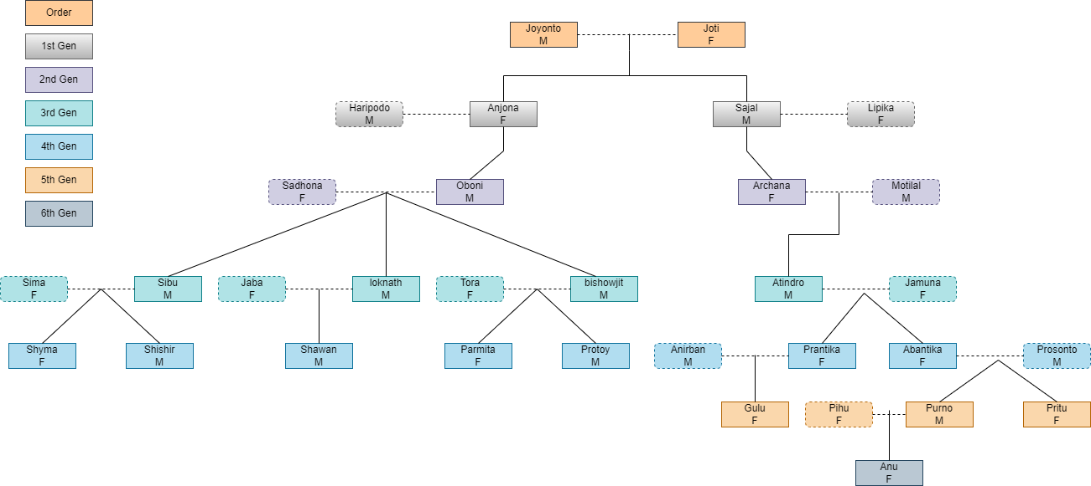

**Necessary Logic:**

|  | R | 2 | 3 | 4 | 5 |
| --- | --- | --- | --- | --- | --- |
| S | Relation | Grandparent | Great GrandParent | Great Great Grandparent | Great Great Great Grandparent |
| 2 | Grandparent | 1st Cousin | 1st Cousin 1st Removed | 1st Cousin 2nd Remove | 1st Cousin 3rd Remove |
| 3 | Great GrandParent | 1st Cousin 1st Removed | 2nd Cousin | 2nd Cousin 1st Removed | 2nd Cousin 2nd Remove |
| 4 | Great Great Grandparent | 1st Cousin 2nd Remove | 2nd Cousin 1st Removed | 3rd Cousin | 3rd Cousin 1st Removed |
| 5 | Great Great Great Grandparent | 1st Cousin 3rd Remove | 2nd Cousin 2nd Remove | 3rd Cousin 1st Removed | 4th Cousin |

**Sample Input/Output:**

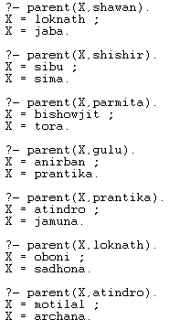 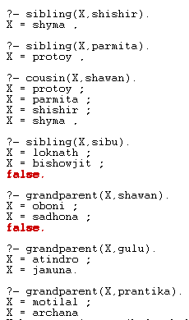 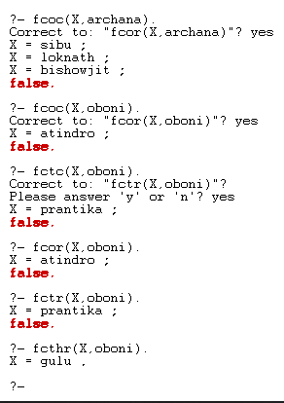 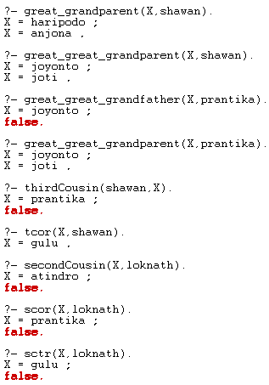

**Source Code:**  [github.com/Shawan-Das](https://github.com/Shawan-Das/CSE-Courses/blob/main/CSE-%20404/Assignment-1.pl)

**Slide:** [Canva/ShawanDas](https://www.canva.com/design/DAFJsklLm1k/jrb3_L9rTz0jUJ4AMBp0nw/view?utm_content=DAFJsklLm1k&utm_campaign=designshare&utm_medium=link&utm_source=publishpresent)

**Challenges & Conclusion:**

Faced some minor difficulties while writing the code. Name and relations should be correctly placed. Facts have to be as simple and specific. There were some errors in SWI-Prolog but those were fixed successfully after some troubleshooting.

To implement any knowledgebase, creating a decision tree and a structured logics can help a lot while troubleshooting. Naming conventions are case sensitive. Be careful of spellings.